GIT and GIT Hub

Create a dir **mkdir story**

Then cd story and create a new file **touch chapter.txt**

Then edit this file **Vim chapter1.txt**

Write a line in it and save by **esc :w** (to save)

To exit the editor **esc :q** this will save and exit **esc :wq**

Now let us try GIT. initialize it by **git init**

.git is an invisible folder that will track all changes. Story btw is the working directory

To see invisible files type **ls -a**

You can put, as per choice, files that you wish to track/versionize into a staging area. To do this , first see what is there with the command **git status** untracked files are shown in red

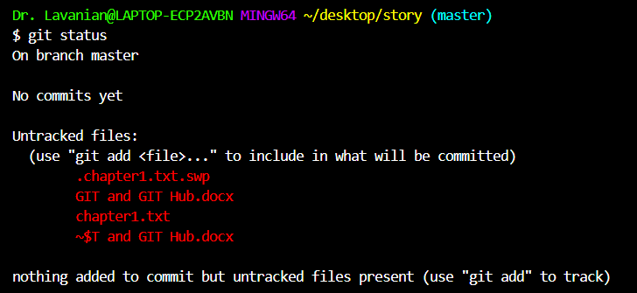

To add files to track simply do git add <file name> in this case **git add chapter1.txt**

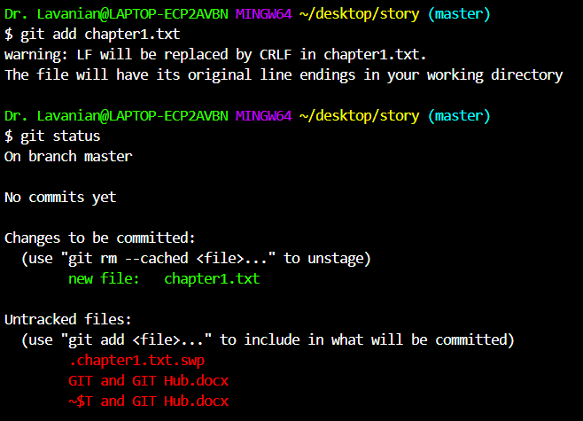

The file/files have not yet been committed, so to commit give the command git commit (it is a good idea to add -m to add your comments so that you know what this version or save is) so the command finally will be **git commit -m “This is the first commit”**

You can also check details in the log with the command **git log**

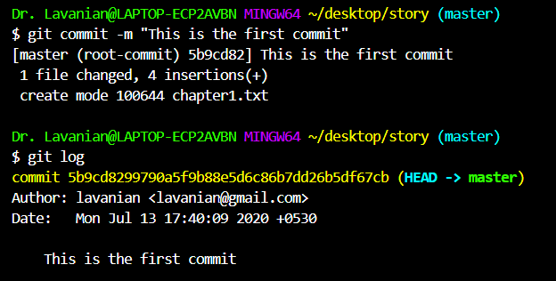

Make another 2 more files chapter 2 and 3 and write something in both

Now **git add** both the files if there are too many files to add you can also write **git add .**

GITHUB

Goto github.com >> create a login>> click on make new repository {right top (+) button} 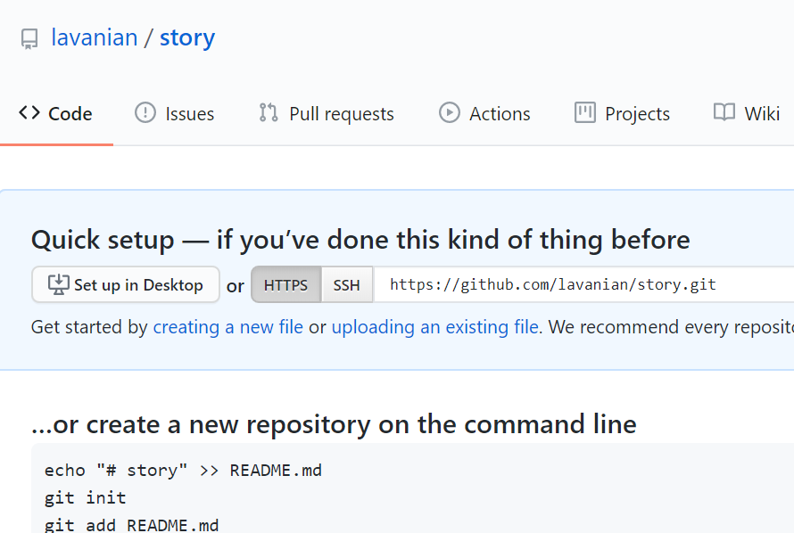

Now we work with the command line to push our repository of ‘story’ onto github

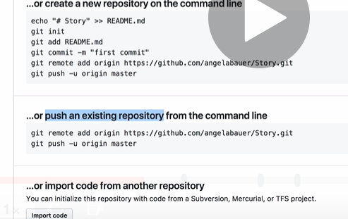

So we use the following code to push our repository to git hub

**git remote add origin https://github.com/lavanian/story.git**

**git push -u origin master**

We now go back to our story directory in Hyperterminal and need to tell our local git that we have an online repository

The command is **git remote add <origin>** (remote is a name of your choice for the remote repository better to keep it the same) command is **git remote add origin**

To this add the url (in this case https://github.com/lavanian/story.git )

**git remote add origin https://github.com/lavanian/story.git**

press enter then give the command **git push -u origin master**

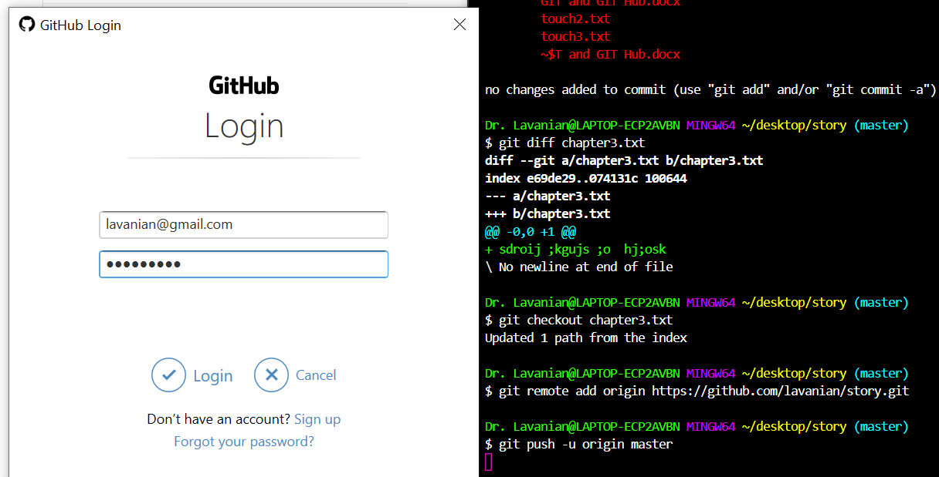 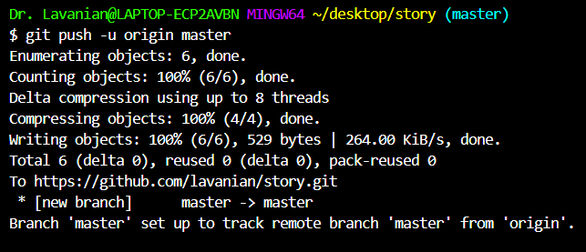

The first version is called the ‘master’ and later ones branches (if we branch)